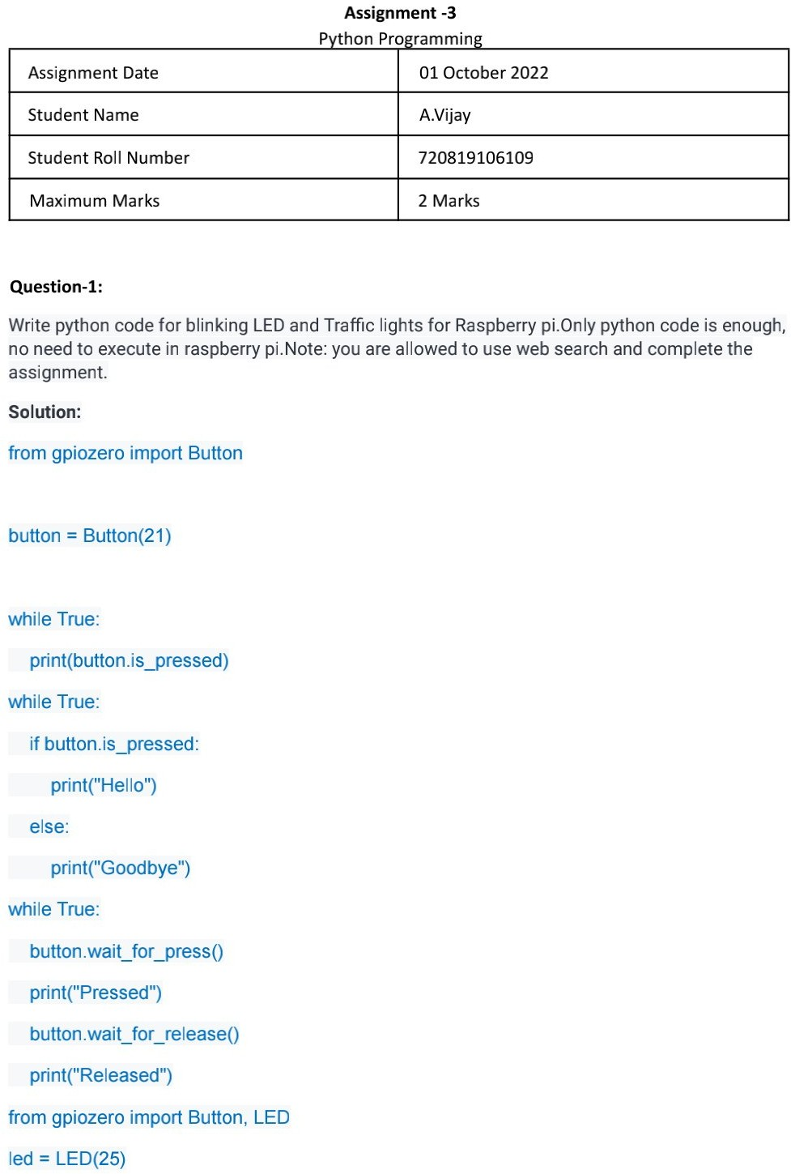

110719106021

N vijitha

110719106018

M pavan kumar

2 Marks

110719106039

Y Balaji

01 October 2022

